Recurrent neural networks are feed-forward neural networks that work on sequential data. They operate on vectors and can either classify the text or can predict the next words in the sequence. RNN introduces a loop-like structure that can pass prior information forward. The hidden state of the network captures essential information and saves them in memory. While processing the hidden state is continuously updated and passed to the next step of the sequence.

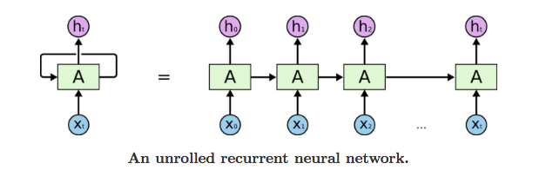

**Data pre-processing**

* Download the dataset here : <https://www.kaggle.com/uciml/sms-spam-collection-dataset> and upload to colab
* Import the necessary libraries
* Read the dataset and drop the unwanted column
* Convert the strings into integers and tokens
* Split the data into train and test dataset

**Building an RNN**

* Use simple RNN function and build a model
* Compile the model and begin to train
* Evaluate the model on test dataset
* Make model predictions on custom data